**ECEN 214 - 302**

**Lab member: Alex Allahar**

**TA: Navid Naseh**

**Date lab performed: 06/23/22**

**Date report is due: 06/26/22**

1. **Procedure**

Task 1 began by measuring the voltage of the 1st AA battery. After measuring this voltage value with the AD2, I placed a 50 ohm load resistor across the terminals of the AA battery. Using the AD2 I measured the load voltage, and then used the multimeter to measure the load resistor actual(measured) value. After recording these two values, I repeated this process for the 6 more load resistor values ranging from 50 to 2000 ohms. I repeated this process for the 2nd 1.5V AA battery.

Next in Task 2, I combined the two AA batteries in series and measures the combined voltage. Similar to the past two circuits, I placed a load resistor across the terminals of the series of AA batteries. I measured the load voltage and load resistor’s actual value. Once these values are recorded, repeat with different load resistor values ranging from 50 to 2000 ohms.

1. **Data Tables**

| RL(Ohms) | RL(Measured) | VL(V) | VL/RL(mA) |
| --- | --- | --- | --- |
| 50 | 56.442 | 1.53 | 27.10747316 |
| 100 | 122.091 | 1.563 | 12.80192643 |
| 200 | 200.77 | 1.586 | 7.899586592 |
| 500 | 538.1 | 1.587 | 2.949265936 |
| 600 | 603.6 | 1.588 | 2.630881378 |
| 1000 | 1010.7 | 1.589 | 1.572177699 |
| 2000 | 1980.9 | 1.59 | 0.8026654551 |

**Figure 1: Task 1 Data(1st 1.5 V AA battery)**

| RL(Ohms) | RL(Measured) | VL(V) | VL/RL(mA) |
| --- | --- | --- | --- |
| 50 | 56.442 | 1.542 | 27.32008079 |
| 100 | 122.091 | 1.565 | 12.81830766 |
| 200 | 200.77 | 1.587 | 7.904567415 |
| 500 | 538.1 | 1.59 | 2.954841108 |
| 600 | 603.6 | 1.592 | 2.637508284 |
| 1000 | 1010.7 | 1.593 | 1.576135352 |
| 2000 | 1980.9 | 1.596 | 0.8056943813 |

**Figure 2: Task 2 Data(2nd 1.5 V AA battery)**

| RL(Ohms) | RL(Measured) | VL(V) | VL/RL(mA) |
| --- | --- | --- | --- |
| 50 | 56.442 | 2.892 | 51.23843946 |
| 100 | 122.091 | 2.987 | 24.46535781 |
| 200 | 200.77 | 2.992 | 14.90262489 |
| 500 | 538.1 | 3.016 | 5.604906151 |
| 600 | 603.6 | 3.042 | 5.039761431 |
| 1000 | 1010.7 | 3.171 | 3.137429504 |
| 2000 | 1980.9 | 3.174 | 1.602301984 |

**Figure 3: Task 2 Data(Both AA batteries in series)**

1. **Sample calculations**

$SE = \frac{σ}{\sqrt{n}}$**Equation 1**

Where n is the number of samples, SE is the standard error, and $σ$ is the sample standard deviation. A version of this equation is used in the Excel formula linest() to calculate standard error of the practical voltage source parameters.

$V_{L}=V_{S}-\frac{V_{L}}{R_{L}}R_{S}$**Equation 2**

This equation uses the slopes of the plots to find the (Vs, Rs) values. Plotting the known values of VL and RL to get the slope ratio VL/RL the unknowns Vs and Rs can be estimated as the y-intercept and the slope. Using this equation and the data table in part B, I got the following plots.

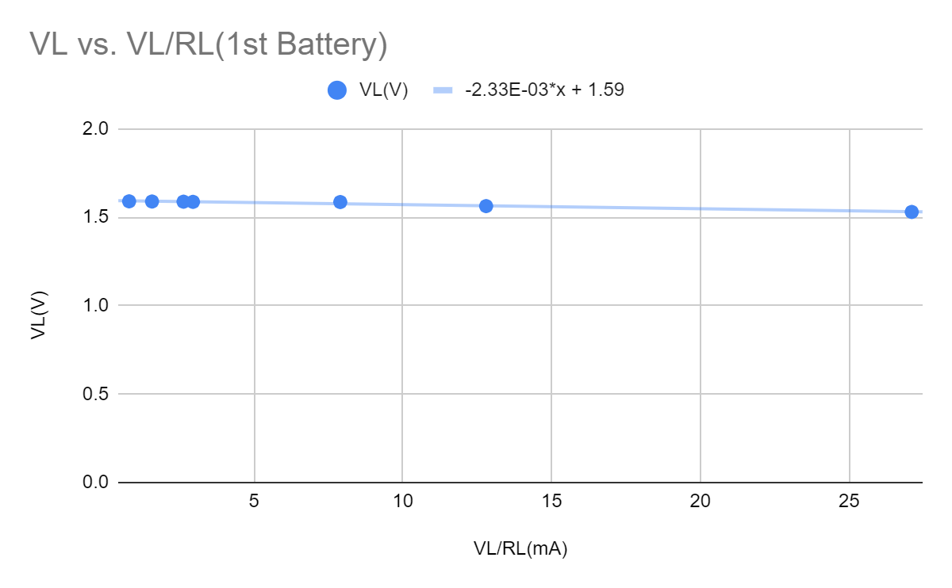

**Figure 4: Task 1 VL vs. VL/RL(1st AA)**

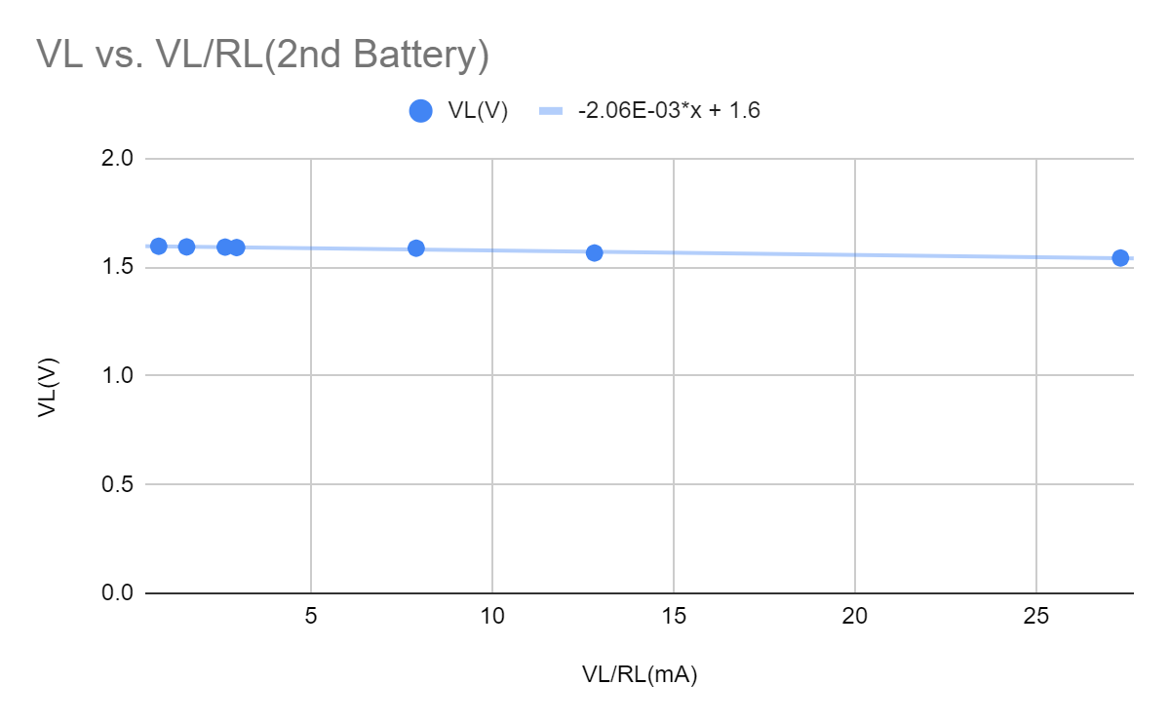

**Figure 5: Task 1 VL vs. VL/RL(2nd AA)**

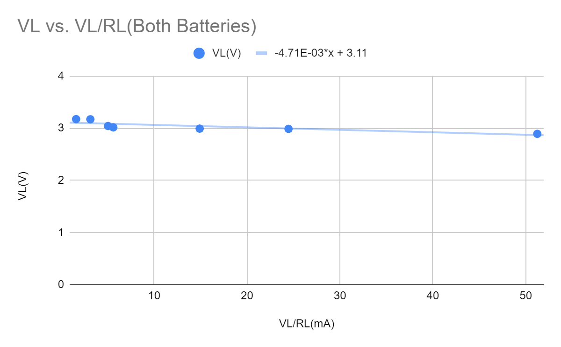

**Figure 6: Task 2 VL vs. VL/RL(Both AA in Series)**

1. **Discussion**
2. One way to estimate error in the estimated values of practical voltage source parameters is to find the standard error of the mean of the data for each parameter, within each task. Using the linearized data from the plots above, and the linest() function creates a least squares regression to estimate the value of the y-intercept and slope, along with the standard error (which is partially based on equation 1) of each. The following results were found below.

For the first 1.5V battery, the source resistance is estimated to be 2.3275 Ohms with a standard error of 0.2056 Ohms. The source voltage is estimated to be 1.5947 Volts with a standard error of 0.0024 Volts.

For the second 1.5V battery, the source resistance is estimated to be 2.0609 Ohms with a standard error of 0.1652 Ohms. The source voltage is estimated to be 1.5972 Volts with a standard error of 0.0019 Volts.

For both 1.5V batteries in series, the source resistance is estimated to be 4.7127 Ohms with a standard error of 1.4571 Ohms. The source voltage is estimated to be 3.1105 Volts with a standard error of 0.0326 Volts.

1. Based on equation 1, I could have reduced the error by taking more measurements of the load voltages for different load resistances. Additionally, for each resistance value, I could have measured the voltage across the resistor several times. I chould have also switched the load resistor setup to be different resistors combination of the same value.